Normals Data and Normals Database Editor



Jacques Régnière
Rémi Saint-Amant
Ariane Béchard

2013

Natural Resources Canada
Canadian Forest Service
Laurentian Forestry Centre
P.O. Box 10380, Stn. Sainte-Foy
Quebec, QC Canada, G1V 4C7

Table of Contents
1. Normals Database 1
1.1. Introduction 1
1.2. Consulting and modifying a Normals Database 1
1.3. Normals Station Editor dialog 3
2. Record structure 4
2.1. Description 4
2.2. Example 5

Normals Database

Introduction

In BioSIM, normals are long-term monthly statistics calculated over 30-year Standard Normal Generating Periods (SNGP), the latest being 1981-2010. These statistics apply to each weather station in the database. A Normals Database contains these monthly statistics for a number of stations, along with the spatial coordinates of each station (latitude, longitude and elevation).

Consulting and modifying a Normals Database

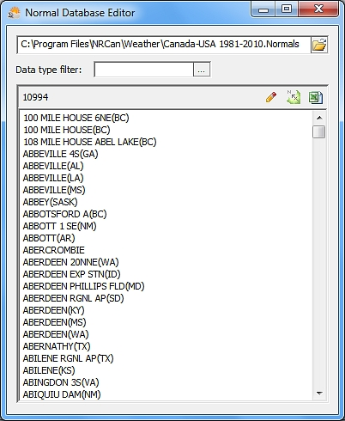
Normals databases can be opened in the Normals Database Editor application.

The Normals Database Editor application can be accessed by selecting [Tools] [Linked Data Editor…] from the menu bar, or by clicking the Linked Data Editor button on the main window’s toolbar.

To access a normals database, the user must select the Normals Databases page  of the Linked Data Editor dialog and either double-click on the desired normals database in the list field, or select a database and click on the Edit button .

BioSIM’s setup usually creates a link between .Normals files and the Normals Database Editor application (unless the user does not have administrative privileges when BioSIM is first installed on a computer).

Buttons and fields available in the Normals Database Editor application are as follows:

The first field shows the file path of the database being displayed in the list field. The Open button in this field can be used to browse for and open another database in the Normals Database Editor.

Data type filter field (browse button ): Select filters to apply to the list of stations. There are four filters to choose from:
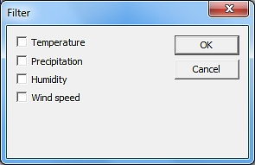
- Temperature (T): Show stations that have temperature data.
- Precipitation (P): Show stations that have precipitation data.
- Humidity (H): Show stations that have humidity data.
- Wind speed (WS): Show stations that have wind speed data.

If all filters are unchecked , every station available in the database will be displayed in the list field. If two or more filters are checked , only the stations that have information on each data type selected will be displayed in the list field.

Edit: Opens the Normals Station Editor dialog allowing the user to access and edit the information contained in the database about a selected station.

Send to ShowMap: Display the location of all the stations listed in the database in the ShowMap application.

Send to Spreadsheet: Sends the coordinates of all the stations listed in the database to the spreadsheet software (e.g. Excel) the user previously specified in the Links page of the Options dialog.

Normals Station Editor dialog

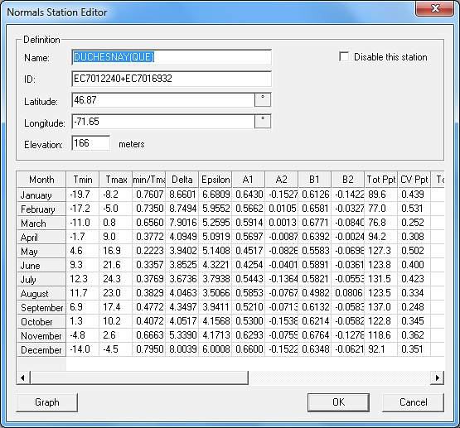
The Normals Station Editor dialog can be opened through the Normals Database Editor dialog by double clicking on a weather station or by using the Edit button .

This dialog can be used to modify data on a weather station. All fields in the Normals Station Editor are editable.

Buttons and fields in this dialog are as follows:

Name field: Name of the normals weather station.

ID field: Weather station identifier.

Latitude field: Latitude coordinate (in the decimal degree system, latitudes south of the equator are negative).

Longitude field: Longitude coordinate (in the decimal degree system, longitudes west of the Prime Meridian are negative).

NOTE: The buttons and on the right of the Latitude and Longitude fields allow the user to display the coordinates either in degrees minutes seconds (DMS) or in decimal degrees (DD) format. However, BioSIM always saves coordinates in decimal degrees.

Elevation field: Elevation of the weather station, in meters (m).

When the “Disable this station” checkbox is checked , BioSIM will disregard this station when the database is used.

button: Opens the PLTWidget application which allows the user to view a graph of the station’s weather data (one graph for each type of weather data).

Record structure

Record structure of the Normals Database

Description

The first line in the .Normals file contains the creation date (Year, Month, and Day) of the Normals Database, the first and the last year of data in summarizes, and the format-version of the database. The second line contains the header fields of the weather variables.

Then come the data themselves. Each station’s record consists of 16 lines in the .Normals file.

1: Weather station name
2: Georeference (latitude, longitude, elevation and use-switch (0: no; 1: yes))

3: Contains Temperatures (No: 0; Yes: 1)
Contains Precipitation (No: 0; Yes: 1)
Contains Humidity (No: 0; Yes: 1)
Contains Wind Speed (No: 0; Yes: 1)
Three other switches are present for later definition
4: Weather station ID
5-16: 12 months of data compiled over a standard period of 30 years. A minimum of 10 years of data within the SNGP must be available for a station to be included in a Normals database. Each line of data is comprised of 16 variables:

- Monthly mean minima (Tmin)
- Monthly mean maxima (Tmax)

From these, normal daily minimum and maximum temperatures are obtained by linear interpolation between the means of successive months adjusted to correspond to the values occurring at mid-month. Seven additional monthly normals are calculated from the differences between observed daily minimum and maximum temperatures and these daily normals:

- Cross-correlation between daily minima and maxima (R Tmin/Tmax)
- Standard deviations of minima (Delta)
- Standard deviations of maxima (Epsilon)
- 1st order autoregressive term for minima (A1)
- 2nd order autoregressive term for minima (A2)
- 1st order autoregressive term for maxima (B1)
- 2nd order autoregressive term for maxima (B2)

Two values describe monthly precipitation:

- Average monthly total precipitation (Tot Ppt)
- Coefficient of variation of monthly precipitation (CV Ppt)

Three values describe monthly humidity:

- Monthly mean dew point (Tdew)
- Monthly mean relative humidity (RH)
- Standard deviation of relative humidity (RH SD)

Finally, two values describe monthly wind speed:

- Monthly mean logarithm of wind speed (in Km/h) (Wind Speed)
- Standard deviation of the wind speed logarithm (Wind Speed SD)

Example

2011 2 28 1981 2010 6
TMIN_MN TMAX_MN TMNMX_R DEL_STD EPS_STD TACF_A1 TACF_A2 TACF_B1 TACF_B2 PRCP_TT PRCP_SD TDEW_MN RELH_MN RELH_SD WNDS_MN WNDS_SD
PUEBLO MEM AP(CO)
38.2900000000 -104.4983333333 1438 1
1 1 1 1 0 0 0
WBAN93058+COOP056740+USC00056740+US1COPU0037
-9.9 8.6 0.5560 5.4282 7.6906 0.6383 -0.0646 0.6064 -0.0093 8.9 0.738 -9.1 58.9 14.781 2.324 0.534
-7.9 10.5 0.5106 5.4375 7.7943 0.6949 -0.0600 0.6274 0.0236 7.6 1.084 -8.2 57.1 15.586 2.433 0.474
-3.4 15.3 0.3350 4.3169 7.0903 0.5588 0.0306 0.6603 -0.1337 23.6 0.686 -5.5 53.2 15.247 2.596 0.444
1.2 19.8 0.3670 3.8061 6.8348 0.5242 0.0469 0.6271 -0.1447 35.6 0.890 -2.4 50.6 15.416 2.733 0.407
6.9 25.1 0.2892 3.2318 5.6561 0.5070 0.0557 0.5995 -0.1083 38.5 0.604 3.6 52.3 14.118 2.687 0.344
11.7 30.9 0.2053 2.8328 4.8198 0.4349 0.0863 0.5923 -0.0916 34.5 0.680 7.4 50.1 13.272 2.658 0.296
15.0 34.1 0.1653 2.4955 3.9270 0.4645 0.1350 0.6539 -0.0876 52.3 0.703 10.4 50.2 12.153 2.598 0.258
14.3 32.1 0.1134 2.3980 4.0041 0.5154 0.0717 0.5978 -0.0720 60.7 0.483 11.2 55.2 11.349 2.516 0.265
8.9 27.8 0.2743 3.3493 5.4432 0.5511 0.0486 0.5193 -0.0074 19.6 0.771 5.5 52.4 12.889 2.487 0.319
1.3 21.0 0.2640 3.8316 6.4219 0.5642 -0.0342 0.5203 -0.0657 18.3 0.967 -1.0 52.4 14.656 2.448 0.398
-5.3 13.6 0.4335 4.4358 7.3455 0.6361 -0.0652 0.5442 0.0437 11.8 1.190 -6.0 56.0 15.720 2.321 0.520
-9.8 8.0 0.5764 5.5309 7.7999 0.6981 -0.0719 0.6196 -0.0028 9.6 0.643 -8.9 59.8 14.306 2.276 0.517

